Alaska Indoor Gardening Curriculum
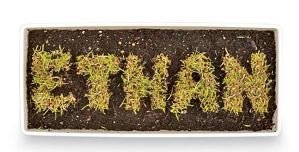
Name in Seeds Lesson
Concept Objective: Soil and Plants
Time: 40 minutes
Setting: Indoors
Activities: Name in Seeds
Materials Needed:
Cardboard Strips – 3”x6” approximately
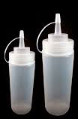
Grass seed
Potting Soil
Aluminum Foil
Condiment squeeze bottles
(an old ketchup or mustard bottle works also)
Flour
Water
Sharpie Markers
Plastic Spoons
Spray Bottle

Procedure:
- Give each student piece of cardboard and aluminum foil
- Have the students fashion the aluminum foil into a box like structure that fits the cardboard. Set aluminum box aside.
- Have the students write their name on the cardboard in pencil.
- Then mix the flour and water in a the squeeze bottle until it has a consistency of glue.
- Have the students squeeze the flour and water mixture on to their name using the squirt bottle.
- Sprinkle with grass seeds and shake extra seeds off.
- Place the cardboard into the aluminum box and cover with soil.
- Spray water on the soil until it is damp, but not too much.
- Advise students on care. Keep in a sunny location and water regularly. If they water regularly, the grass will grow in the shape of their names.

